https://papertrailapp.com/systems
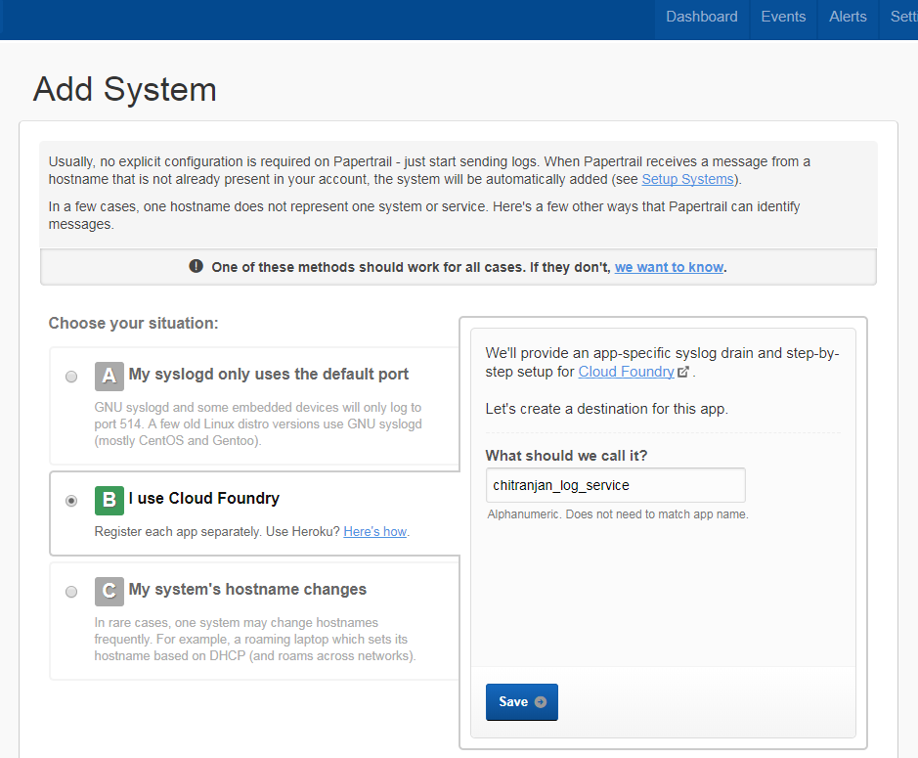

STEp2::
After save note the log url
Eg:
logs.papertrailapp.com:37751
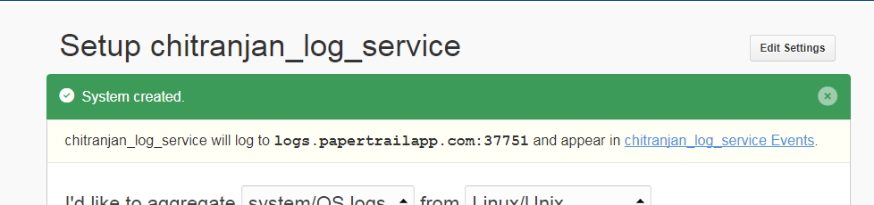

cf create-user-provided-service log-drain -l syslog://logs.papertrailapp.com:40685

